Genetic Progress or Genetic Danger?
Posted by Richard Tsai on Mar 5, 2015 11:00:00 AM
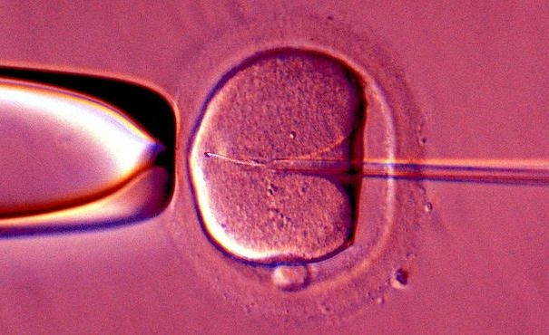
In early February, Great Britain’s House of Commons followed a historic debate with a vote approving a 2015 amendment to the 2008 Human Fertilization and Embryology Act. The new modification allows an additional person to donate mitochondrial DNA for In Vitro Fertilization (IVF) babies. The mitochondrial DNA donation from a third person is just 0.054 percent of the baby's entire DNA, but is able to protect from serious genetic diseases.
There are two ways to perform the transfer; the first is pronuclear transfer where a fertilized egg zygote is moved to a matched donor zygote with its nucleus removed. The second way is known as spindle transfer. The spindle transfer is accomplished by transferring maternal nucleus into a donor egg where its nucleus has also been removed.
What is Mitochondrial Disease?
The cause of mitochondrial disease is directly related to the failure of the mitochondria. These are specialized cells found in every part of the body except red blood cells. The job of mitochondria cells is to create 90 percent of the energy that a human body needs for continued life and support. If these cells fail, they generate an ever diminishing amount of energy. The end result is cell injury followed by cell death. As the process of cell failure continues throughout the human body, bodily systems and organs begin to fail compromising the life of the person experiencing the cell failure, often symptoms include;
- Pain
- Swallowing difficulties
- Loss of motor control
- Lactic acidosis
- Gastrointestinal problems
- Hearing and vision problems
- Compromised immune system
- Developmental delays
Mitochondrial disease seems to damage most severely the cells of the heart, brain, kidney, endocrine system, liver, skeletal system, and the respiratory system. Normally, a mitochondrial disease affects children, although adult onset does occur.
The Debate and the Vote
Support was overwhelmingly in favor and the vote was 382-128, which comes to a massive 254 majority. However, critics warned that the new regulations will create “three-parent” children. According to Jane Ellison, the Conservative public health minister, the new regulation offers the only way for some women carrying the disease to have babies that could grow up to be “healthy, genetically-related children.” Further, these children will avoid the suffering of “devastating and often fatal consequences from mitochondrial disease.” She also stated that as the amount of DNA is only 0.054 percent of total DNA, none of the nuclear DNA implanted will impact personal traits and characteristics.
The bill's opponents have said the evidence is unclear if the technique is safe or ethical. In Parliament, the opposition leader was a Conservative MP, Fiona Bruce. She said;
“I believe the regulations before us today fail on both counts, ethics and safety, and they are inextricably interlinked. One of these procedures we are asked to approve today, pronuclear transfer, involves the deliberate creation and destruction of at least two human embryos, and probably in practice many more, in order to create a third embryo which it is hoped will be free from human mitochondrial disease. Are we happy to sacrifice two early human lives to make a third?”
A number of other MPs expressed their dissatisfaction with the shortness of the debate which lasted 1.5 hours. Others against passage claimed the technique will be used to create “designer babies.”
Late in February, the bill was debated for three hours in the House of Lords and then passed.
How This Bill Helps
With the bill now law, the first mitochondrial transfer babies are expected to be born sometime early next year. In Britain, 2500 families live with the chance of mitochondrial disease being passed on by mothers to children. Each year about 100 babies are born with a mitochondrial disease. Babies born IVF with a mitochondrial transfer have 99.8 percent of their DNA that comes from their parents, and 0.2 percent of a female donor. The small amount of transferred mitochondrial cells is outside the nucleus of cells.

The Future of Mitochondrial Transfer
The success of this technique in England doesn’t necessarily promise its future throughout the rest of Europe. Fifty Italian members of Parliament petitioned the House of Lords to reject the bill. Additionally, there is some concern that the new regulations are contrary to European Union law. However, petitions from groups in Germany, France, and Spain were sent to Parliament supporting the change.
The petitions said,
"Mitochondrial disease is unimaginably cruel. It strips our children of the skills they have learned, inflicts pain that cannot be managed, and tires their organs one by one until their little bodies cannot go on any more."
Mitochondrial Disease and the Pharmaceutical Industry
In the United States, mitochondrial transfer is under the authority of the Food and Drug Administration (FDA). In 2001, they banned a very similar procedure known as cytoplasm transfer, in their letter to clinics doing the procedure the FDA said;
"Injecting cytoplasm from a young egg into the cytoplasm of a new egg without removing any existing material, the FDA must conduct a clinical investigation, which can't even start until an Investigational New Drug (IND) application has been filed."
Although the letter is now 15 years in the past, as of now not a single clinic has been approved for cytoplasm transfer or mitochondrial transfer in the United States. An FDA spokesperson said that the FDA is not allowed to comment on whether any IND applications have been filed.
Worldwide, this disease is not going to make any drug company a lot of money as the incidence of mitochondrial disease is relatively small, about 11.5:100,000 or about 1 of 8,500. Additionally, developing a pharmaceutical product requires a billion dollars or more, with no guarantee of being able to market it. This explains why some drug companies are researching and developing pediatric drugs to help victims of mitochondrial disease manage symptoms better and have a better quality of life.
As research and development efforts explore new and innovative ways to cure diseases, we continue to see an industry trend of pushing controversial boundaries. This highlights the importance of agencies like the FDA to act as gatekeepers in ensuring research practices are fully vetted and that the proper guidelines are in-place.

